**Microsoft Project 2016: Tutorial 6**

**Tracking Progress**

In this tutorial, you will learn how to keep track of project progress. Having completed a plan, a project can start. However, it is not uncommon for a project plan to have to change during the project. For example, a task might take longer to complete than was originally estimated, or a resource might become unavailable (e.g. staff illness). A Project Manager should always keep track of project progress. MS Project provides several tools to help with this – the first one that you will look at is called a Baseline.

A Baseline is a group of reference points (including start dates, finish dates and durations) that you can set as a record of the original project plan. If and when a project plan changes, the Baseline can be used as a means of comparing planned progress against actual progress.

This tutorial assumes that “SimpleSoftwareProject” has now started. To model this, you need to change the project start date to 2 days ago (i.e. if today is “03/11/2016” you need to set to project start date to “01/11/2016”). The screen shots used here assume a “01/11/2016” start date.

**1. Getting started**

Start MS Project and open “SimpleSoftwareProject”.

**2. Create a Baseline**

Switch to the Project tab and from the Schedule group select Set Baseline:

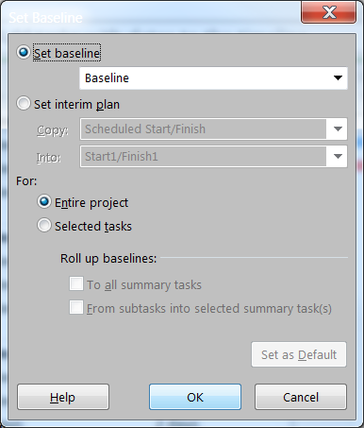

The Set Baseline window will appear. Accept the default values by clicking on OK.

To view the Baseline switch to the View tab and from the Task Views group select Gantt Chart (it is probably already selected).

Now switch to the Format tab and from the Bars and Styles group select Baseline. From the list that appears, select the Baseline that you just created (it should be at the top of the list). The Gantt chart should now be displaying Baseline Gantt bars (coloured grey) together with the current Gantt bars:

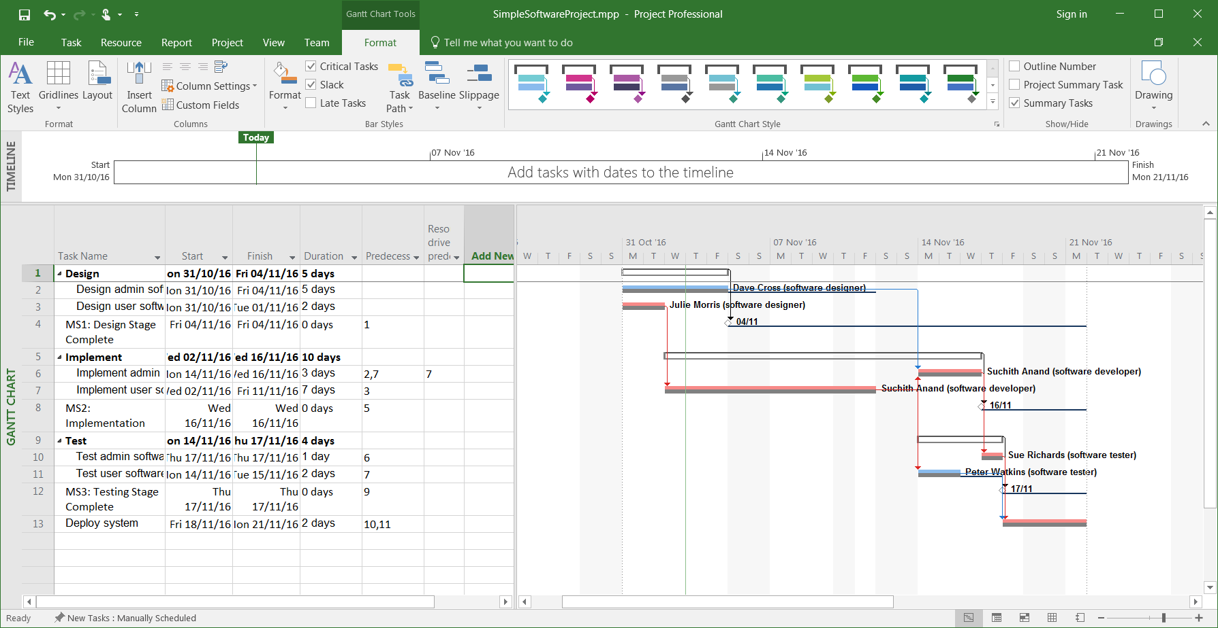

**3. Change the plan**

OK, imagine the situation where the “SimpleSoftwareProject” has been running for 4 days. Unfortunately, there has already been a delay (for whatever reason) with one of the tasks. Task 3 (Design user software) was due to complete in 2 days, but is now likely to take 3 days.

This change can be introduced into the MS Project plan simply by changing the Duration value of Task 3 to 3 days. (If the Duration column is not showing, add it using the Add New Column drop-down menu, as described in a previous tutorial):

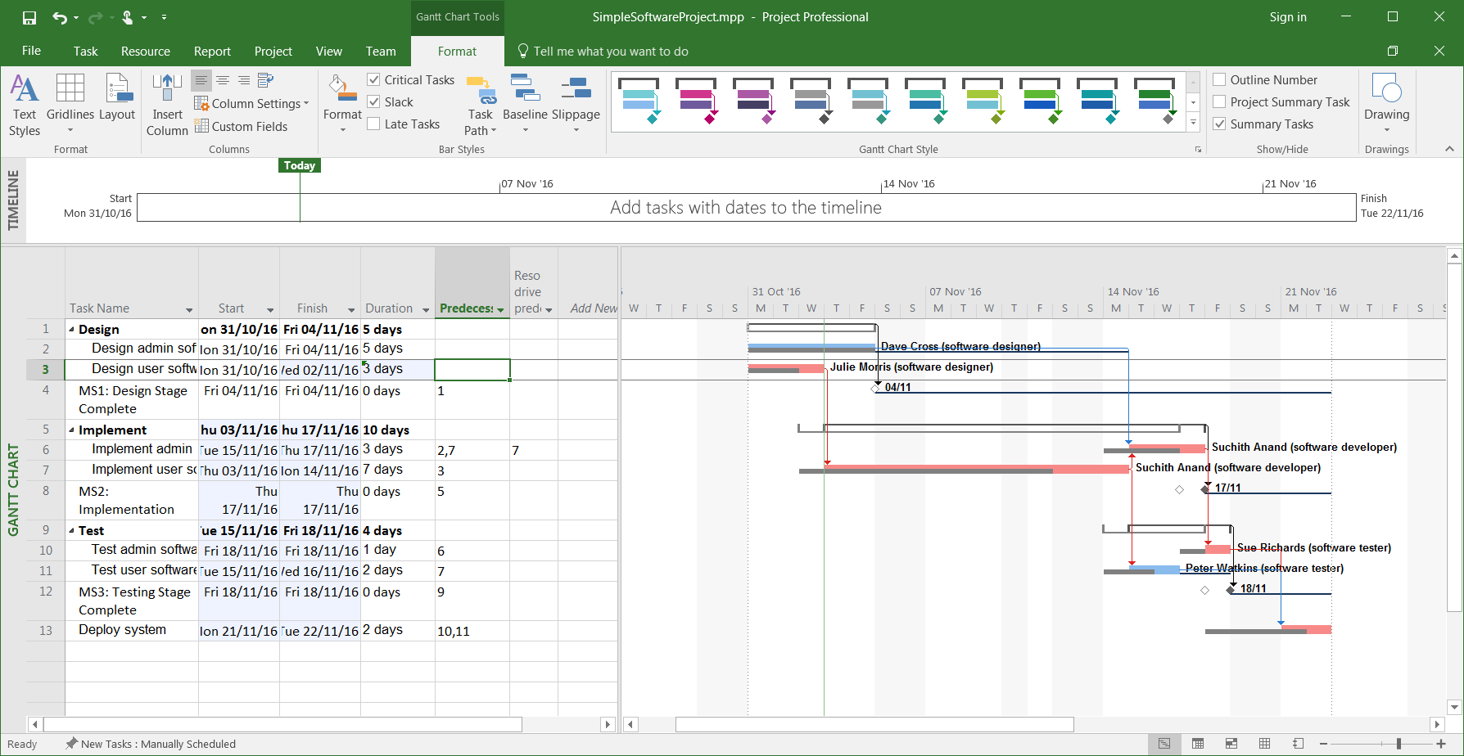

As you might expect, this results in a change to the Gantt chart. Notice that the Baseline bars have not changed – they have remained in their original positions, and now provide a means for checking actual project progress against the original plan.

NOTE – MS Project 2016 allows you to add multiple baselines to a project and its tasks, and to update a baseline. This tutorial is only concerned with a single baseline.

**4. Interim Plans**

An interim plan is a set of current project data that you can compare against the Baseline to check the project’s progress. An interim plan only saves current start and finish dates.

To set an interim plan, switch to the Project tab and select Set Baseline from the Schedule group:

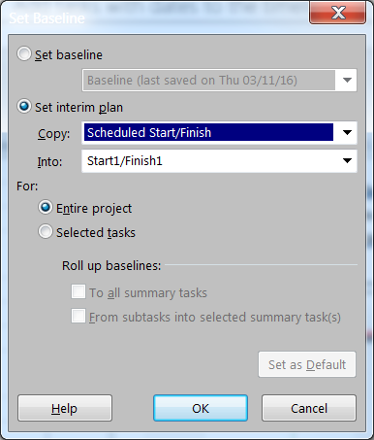

Select the Set interim plan radio button. In the Copy box, click the start and finish or baseline values that you want to save. In the Into box, select the name of the interim plan into which you want to save the values. Select the Entire project radio button. Click OK.

You can view the Start1/Finish1 values by adding the Start1 and Finish1 columns to the task grid panel. This provides you with another means of comparing planned against actual progress:

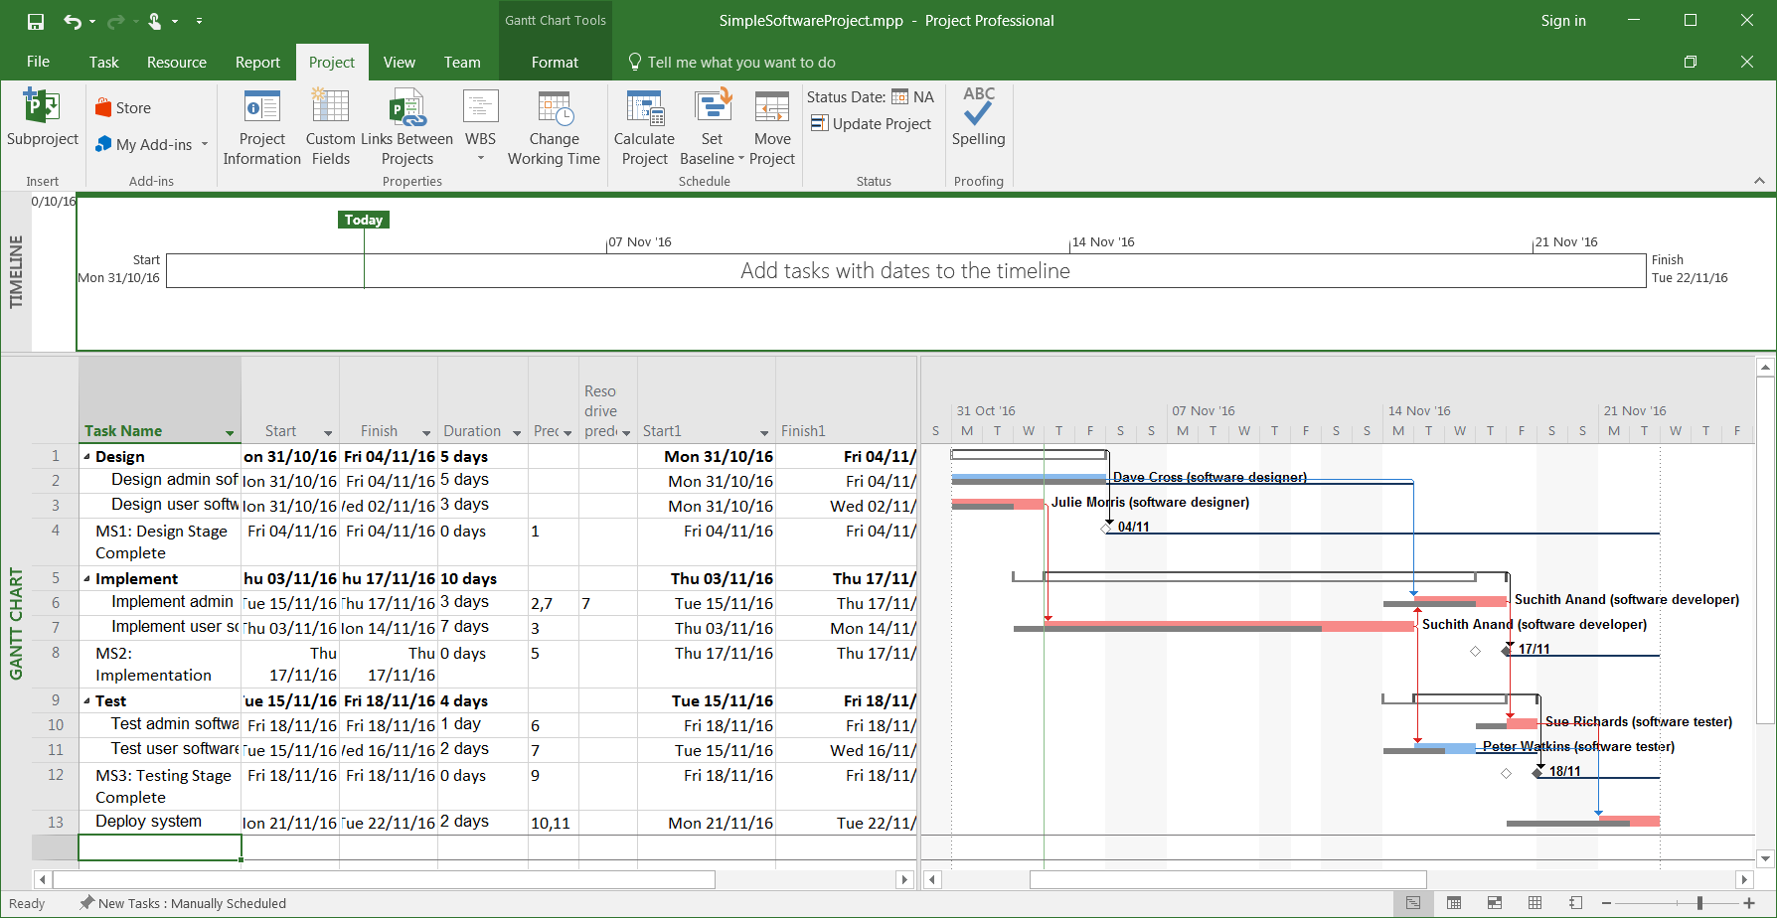

MS Project 2016 allows you to set up to 10 interim plans per project.